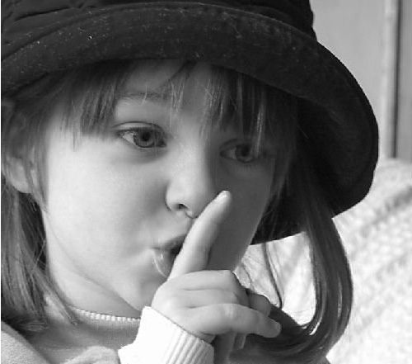

**Please be respectful of those who are studying for their exams, and good luck to all!**

**24 Hour Quiet Hours!!!**