Change Drive
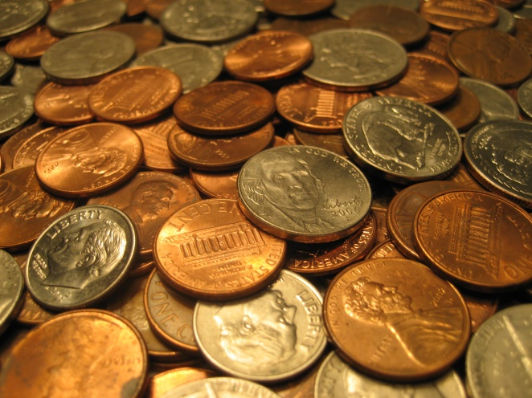
Ra’s from hickory, elm, and sullins are teaming up to collect change to donate to the recovery of Gatlinburg. We will be coming around Monday, 1/30, to collect spare change. All proceeds are appreciated!

